Layout of proposed work
Optimization of the roof and walls of Pradhan Mantri Awas Yojna (PMAY) by retrofitting the PCM layer to achieve thermal comfort and reduce energy consumption
We are trying to achieve the thermal comfort of Pradhan Mantri Awas Yojna’s building by integrating the n-octadecane PCM layer in different configurations of buildings, like on walls and roofs. By doing this, we optimize the best configuration that consumes less energy and gives maximum thermal comfort.
Important steps
- Location:- Hot and humid climate (Kharagpur or Kolkata)
- Different configurations:
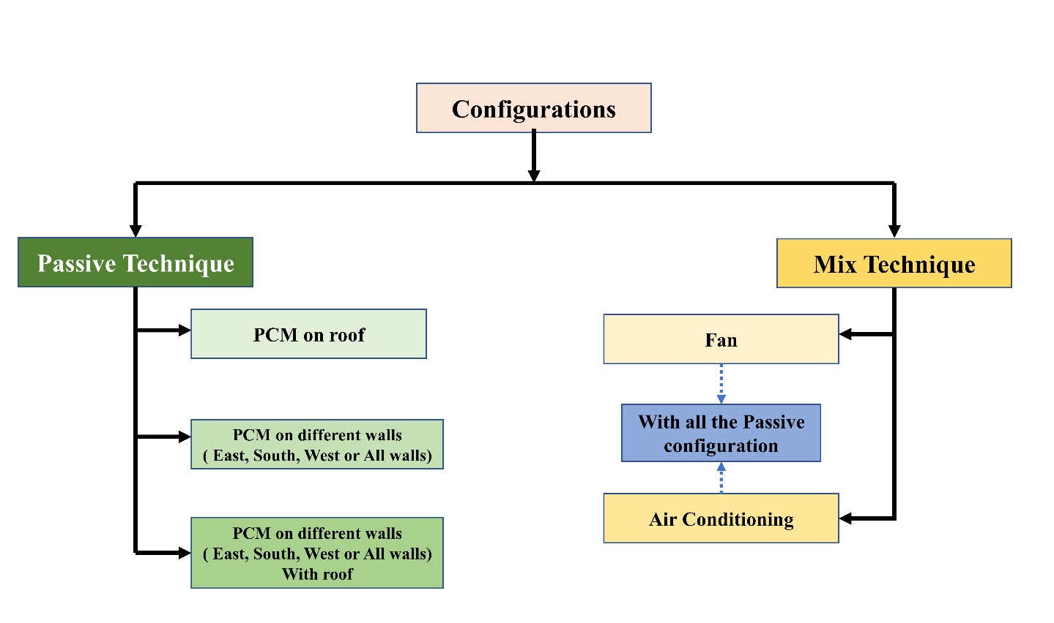
- Objective:- Identify best possible configuration to get maximum thermal comfort and reduce the energy consumption
- Probable results:
  - Summer Vs Winter (PCM performance)
  - Energy Performance Index
  - Comfort Vs. Energy consumption (Adaptive or PMV)
Optimasition technique will be finalized after the literature review (I am trying to learn NSGA-III )

PMAY Layout
Source: Urban Development & Municipal Affairs Department Government of West Bengal
